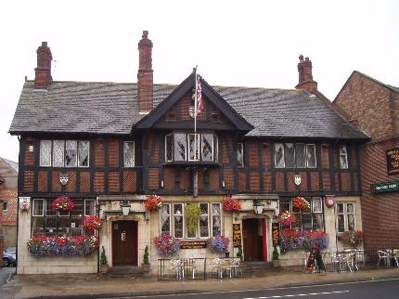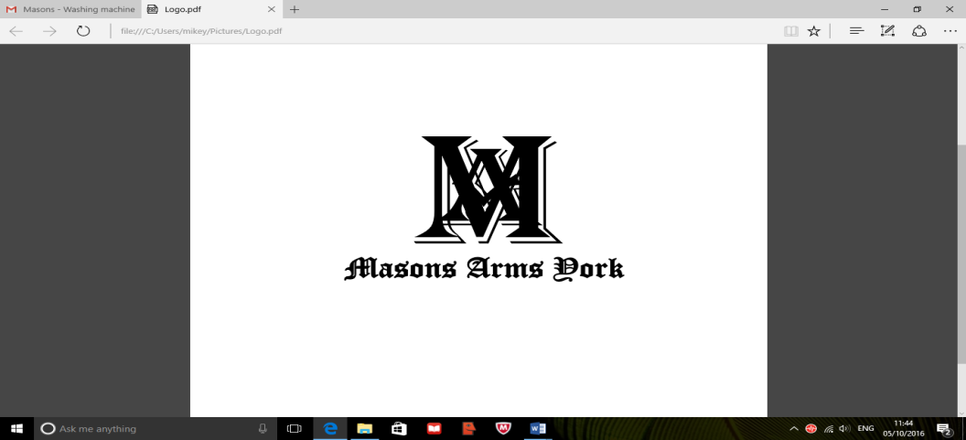

**One time only BBQ to mark the one year anniversary of our opening, following the devastating floods that occurred Boxing Day 2015.**

**On the BBQ:**

**Burgers £4.00**

**Sausages £3.50**

**Extra Toppings £0.50**

**Bowl of chips £2.00**